# **CSE211 Web Programming, Fall semester 24/25**

# **Assignment#1: Websites conceptual Design and mock-up**

# **Name:Abdelrahman Gamal Zakaria, ID:222100933**

# **Let’s talk about the core idea about steveEdito’s:**

# The core idea of **Steve Editor** is to make editing telecom billing files easy and accurate for telecom professionals. It helps manage billing data between network operators, ensuring files meet industry standards, saving time, and improving efficiency.

# **2.3.1.part1: research:**

# **1.The defining characteristics of Web 2.0 to Web 4.0 are:**

# Web 2.0: Participatory Web, emphasizing user-generated content and interactivity and graphic design.

# Web 3.0: Semantic Web, focusing on structured data and AI-powered and some security solutions.

# Web 4.0: Symbiotic Web, leveraging AI and machine learning for personalized experiences and make us to use web easier.

# **2.The key features of Web 2.0 and how it empowers the power of networks are:**

# Web 2.0, also known as the "Social Web," is characterized by its focus on user-generated content, interactivity, and visual enhancements. Unlike its predecessor, which mostly consisted of static pages, Web 2.0 enables users to actively participate by creating and sharing content. This interactive layer makes Web 2.0 a space where communities and collaborations thrive. Key features include social media platforms, blogs, wikis, and social bookmarking, where users contribute, rate, comment, and share information, leveraging the power of networks to faster a more democratic. In essence, Web 2.0 empowers users to engage in meaningful connections, knowledge-sharing, and artificial intelligence, making it easier to access diverse perspectives and creative ideas.

# **3.The key features of Web 3.0 and how it empowers the meaning of data and knowledge connections are:**

# Web 3.0, often called the "Semantic Web," enhances the meaning and usability of data. This evolution introduces structured data, metadata, and a layer of AI-powered solutions, making information easier to understand and interconnect. Web 3.0 uses linked data principles and semantic tagging, which allows the web to “understand” relationships between concepts. AI and machine learning are integral to Web 3.0, enabling intelligent searches, automation, and personalization based on users' preferences. Enhanced security measures, powered by AI, ensure a safer browsing experience with better threat detection and response. As a result, Web 3.0 not only organizes information efficiently but also facilitates knowledge discovery, transforming the web into a more interconnected and intelligent resource that "understands" users’ needs and provides relevant and easy content.

# **4.The key features of Web 4.0 and how it empowers the intelligence connections are:**

# Web 4.0, sometimes referred to as the "Symbiotic Web," pushes user experience to the next level through advanced AI, machine learning, and natural language processing (NLP). This generation of the web harnesses data from various devices to deliver personalized experiences, from customized news feeds to targeted recommendations. It emphasizes seamless interactions through voice and thought interfaces, enabling hands-free, real-time responses. Web 4.0 is also marked by inter-device communication, creating a connected ecosystem of devices, where users can control and access information effortlessly across platforms. By integrating natural language comprehension and deeper AI-powered functionalities, Web 4.0 adapts intuitively to users, making the web experience more interactive, efficient, and personalized. It represents a web that not only interacts with users but learns from them, continually improving to offer a frictionless, user-centered and more experience.

# **5.The importance of collective intelligence, social networking, social media, and social bookmarking is:**

# Enabling information sharing, collaboration, and community building.

# Facilitating collective intelligence and knowledge discovery.

# Empowering businesses to understand trends and consumer preferences.

# **6.These technologies empower current and future business plans by:**

# Enabling data-driven decision-making and personalized customer experiences.

# Improving operational efficiency and reducing costs.

# Enhancing customer engagement and loyalty.

# **7.I intend to use the latest technologies in my profession by:**

# Utilizing AI and machine learning tools for intelligent insights and improved automation to help me in my tasks.

# Leveraging natural language comprehension and voice interfaces for seamless interactions to make the problem successful easier.

# **2.3.2.part2: website planning**

# **1.Define the purpose of your intended website:**

# The purpose of SteveEditor's website is to establish an online presence for SteveEditor, a professional editing and writing services provider. The website aims to showcase SteveEditor's expertise, services, and portfolio, while also providing a platform for potential clients to learn more about the services offered and get in touch with SteveEditor.

# **2.What would you like the website to accomplish?**

# SteveEditor's website aims to accomplish for:

# Establish credibility and trust with potential clients

# Showcase SteveEditor's expertise and portfolio

# **3.Who is your intended audience?**

# The intended audience for SteveEditor's website includes:

# Potential clients who are looking for editing and writing services

# Existing clients who need to access resources and communicate with SteveEditor

# **4.What opportunities, problems, or issues does your planned website address?**

# The website addresses the following opportunities, problems, or issues:

# Providing a centralized platform for SteveEditor's services and portfolio

# Increasing visibility and credibility for SteveEditor's business

# **5.What kind of content could be incorporated on your website?**

# The following types of content could be incorporated on SteveEditor's website:

# About page with bio and services overview

# Portfolio section showcasing editing and writing projects

# **6.How will the site serve the client?**

# Providing a centralized platform for accessing resources and communicating with SteveEditor

# **7.What's the best method for the user to do what's wanted?**

# The best method for users to accomplish their goals on SteveEditor's website will depend on their specific needs and goals. However, the website will be designed to be user-friendly and intuitive, with clear navigation and calls-to-action to help users find what they're looking for.

# **8.How will users find the function?**

# Users will be able to find the function on SteveEditor's website by:

# Using the navigation menu to access different sections of the website

# Searching for specific keywords or phrases using the website's search function

# **9.How will the results of the function be received?**

# The results of the function on SteveEditor's website will be received through various means, including:

# Email notifications when a user submits a contact form.

# Automatic responses to user inquiries or requests.

# Access to download resources or documents.

# **10.What will the receiver do with the received entries?**

# The receiver (SteveEditor) will:

# Review and respond to user requests.

# Update the website's portfolio or services section with new projects or services.

# Use the received entries to improve the website's content and services.

# Follow up with users to provide additional information or support.

# **11.How will the receiver deal with results?**

# SteveEditor will deal with the results by:

# Reviewing and analyzing user feedback and inquiries to improve the website and services

# Updating the website's content and services to reflect user needs and preferences

# Providing personalized responses and support to users

# **12.What follow-up will be needed?**

# Follow-up will be needed to:

# Respond to user inquiries and requests

# Provide additional information or support to users

# Update the website's content and services based on user feedback

# Monitor and analyze website analytics to identify areas for improvement

# **13.List at least two related or similar sites found on the Web. Explain why you chose them:**

# ProWritingAid: This website offers a range of writing and editing tools, including grammar and spell checkers, as well as resources for writers and editors. I chose this site because it is a well-established and reputable resource for writers and editors, and it offers a range of tools and services that are similar to those offered by SteveEditor.

# Reedsy: This website is a platform that connects authors with professional editors, designers, and marketers. I chose this site because it is a well-known and respected platform in the publishing industry, and it offers a range of services that are similar to those offered by SteveEditor.

# I chose these sites because they are both well-established and reputable resources in the writing and editing industry, and they offer a range of tools and services that are similar to those offered by SteveEditor. By studying these sites, SteveEditor can gain insights into how to improve its own website and services, and how to better serve its users.

# **Website Goal:** The goal of SteveEditor's website is to provide a platform for freelance editors to showcase their services, connect with potential clients, and manage their projects efficiently.

# **Describe the content:**

# **Working Titles of Pages [Home Page]:**

# SteveEditor(home)

# Main page

# About page

# Program page

# Contact page

# **Page Contents:**

# **Home Page:**

# Header with logo and navigation main

# Space image or video showcasing SteveEditor's services

# Brief introduction to SteveEditor and his services to clients

# Header with social media links and contact information

# **Main Page:**

# **Content:** Detailed description of the benefits for telecom professional’s editors.

# **About Page:**

# **Content:** Background on Steve Editor,the development team, and their goals.

# **Program Page:**

# **Content:** Focused overview of specific features, for ex: editing and compliance support.

# **Contact Page:**

# **Content:** Contact information, support hours, and comments on social media.

Home

Program

About

Main page

Contact

Content about Steve editor

The client that what will study at edit

Service for client

Social media

# **2.3.3. Part 2: website design**

# **[A]**

# **1.Law of Prägnanz**: Each page will have a clean, simple layout, minimizing clutter so that users can focus on key actions (like buy now for premium).

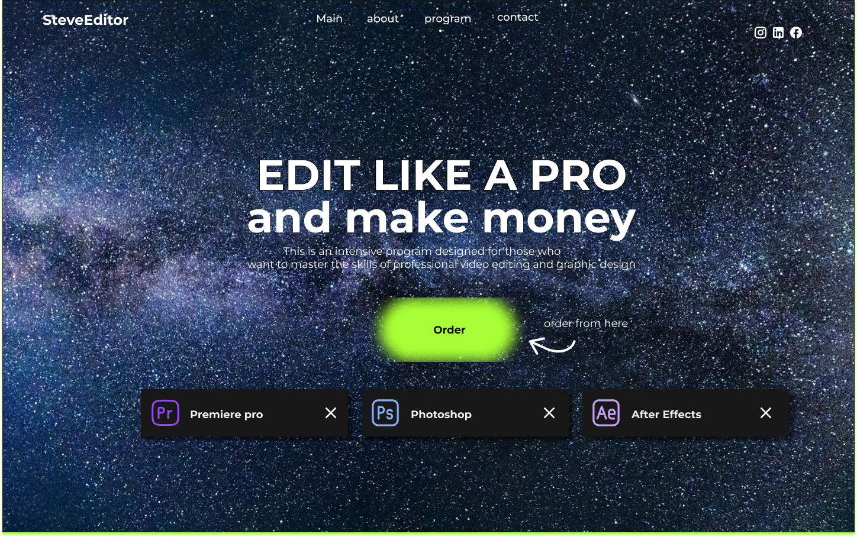

# **2.Closure**: Elements like headers and feature lists will use subtle framing to guide users' eyes, creating complete shapes that help communicate the page's overall message and content.

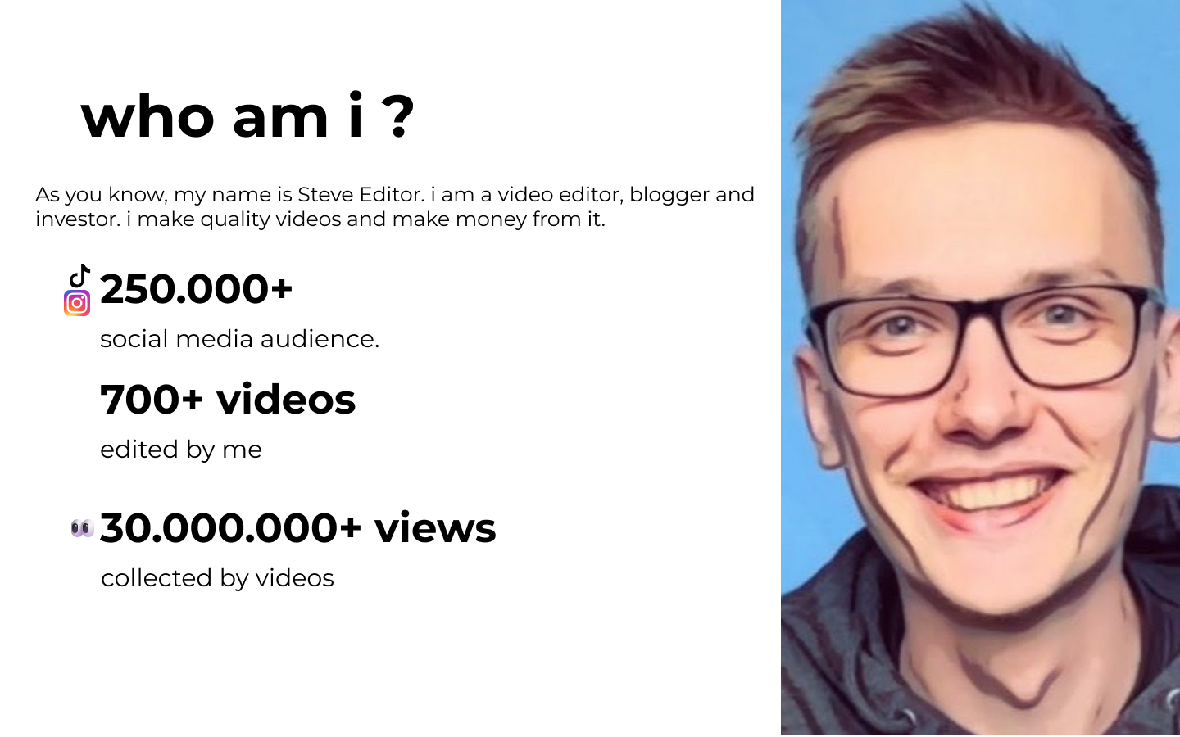

# **3.Symmetry and Order**: A balanced layout will emphasize consistency and professionalism, using grids to keep information visually organized easier.

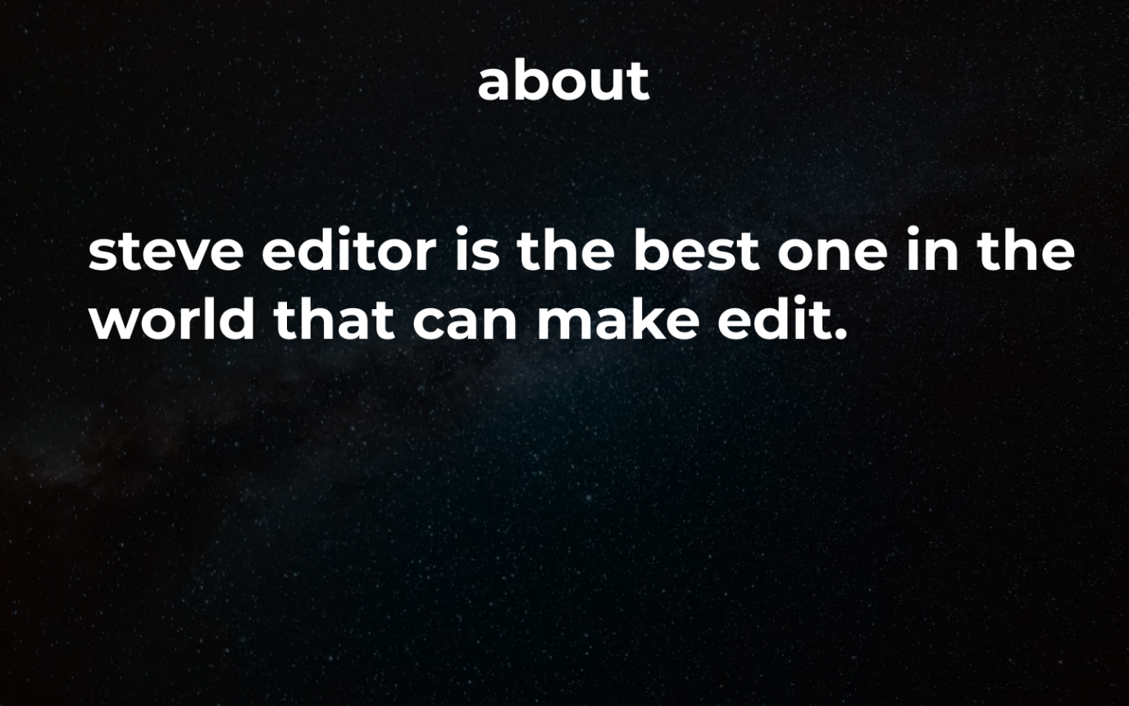

# **4.Figure/Ground**: Distinct sections with sample whitespace around main content areas (like feature highlights) will help users immediately distinguish content from background.

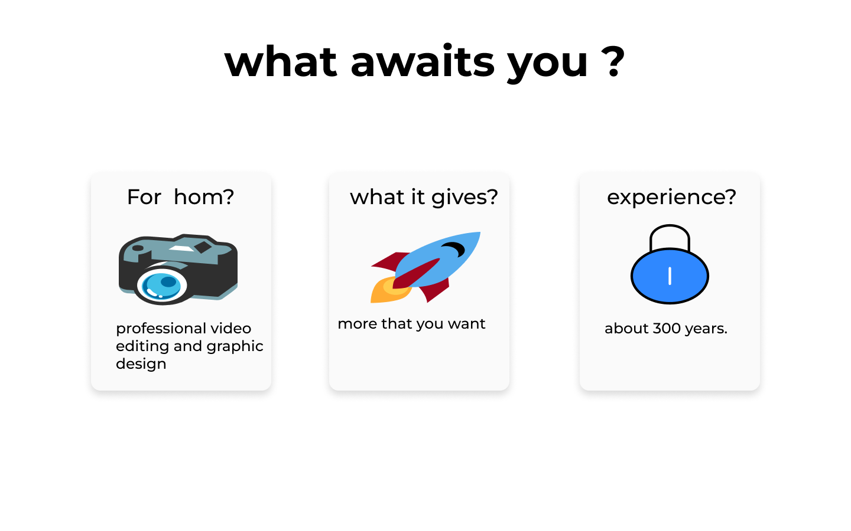

# **5.Uniform Connectedness**: Related content will be grouped with similar colors or lines, making it clear which elements belong together faster.

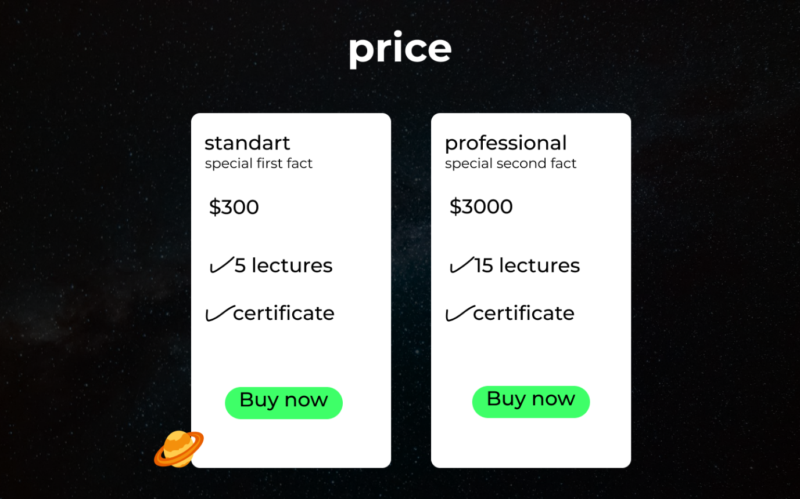

# **6.Common Region**: Borders or background color blocks will surround related sections, like support, contact information, and main to separate them from unrelated areas.

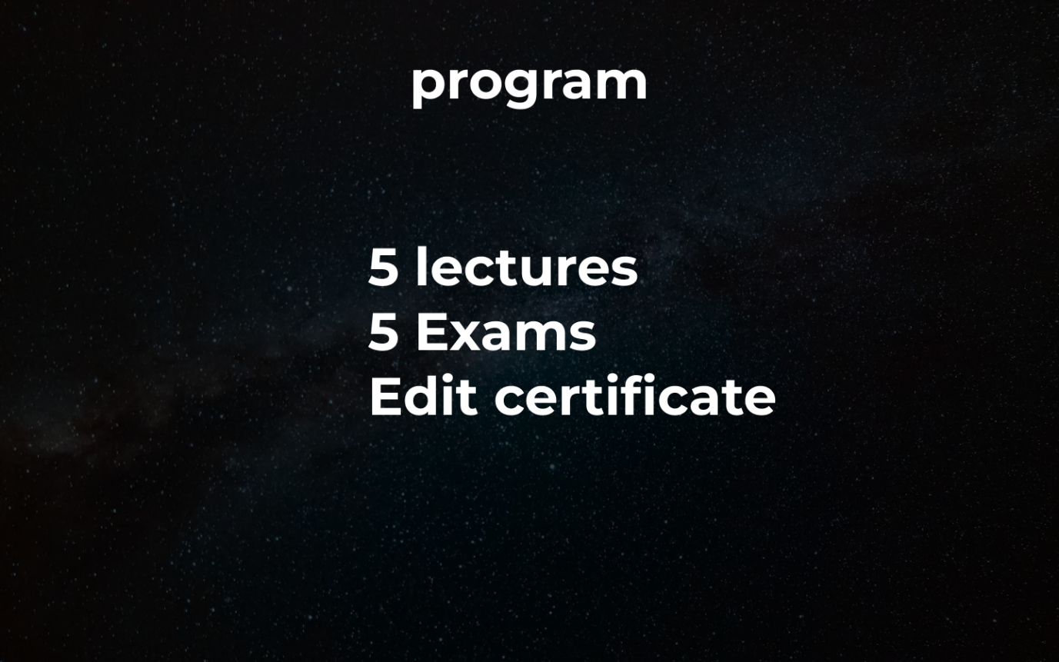

# **7.Proximity**: Grouped elements, such as FAQs under Support, will have tighter spacing, while unrelated sections will be spaced apart to visually indicate different purposes and content on social media.



# **8.Continuation**: Scrolling down from the Homepage to deeper sections will follow a natural flow, using arrows and icons to guide the user easier through the page.

# **9.Common Fate (Synchrony)**: Interactive elements (buttons or tabs) will appear, indicating their shared functionality.

# **10.Parallelism**: Aligned sections, such as feature descriptions in columns and rows, will suggest uniformity, reinforcing the professional and dependable nature of Steve Editor.

# **11.Similarity**: Fonts and icons with consistent styling across the website will unify the content, making navigation intuitive and user-friendly faster.

# **12.Past Experience**: Common design conventions, like a sticky navigation bar and standard icons will meet users' expectations and increase usability easier.

# **[B]**

# **1.Screen Resolution:**

# **Responsive Design:** Design will adapt across multiple resolutions ex:1910x1060 for desktops, 374x664 for mobile,563x678 for tablets to ensure accessibility on some devices.

# **2.Color Palette:**

# **Palette Selection:** You can use tools like Adobe Color Wheel CC or Paletton to create a palette that suits Steve Editor’s brand. Typically, black or white tones convey reliability and tech-oriented themes and pictures.

# **3.Minimum Contrast for Accessibility:**

# **Contrast Ratio:** A minimum contrast ratio of 4.5:1 will be maintained to meet ensuring readability for users with visual theme.

# **4.Front-End Development Technologies:**

# **Technologies:** HTML5, CSS, JavaScript will create a smooth, responsive user experience with interactive elements.

# **5.Content Management System (CMS):**

# **CMS Options:** WordPress could be suitable for managing updates, user comments, and news/blog posts about Steve Editor updates and edit.

# **6.Back-End Development Technologies:**

# **Technologies:** PHP could power the back end, with databases like MySQL or MongoDB for data storage and GUI, while hosting might be on AWS or digital ocean for scalability.

# **7.Metrics for Measuring Website Performance:**

# **Key Metrics:** Page load speed, bounce rate, user engagement and error rates will measure performance by efficiency.

# 8.**HTML5 Page Structure:**

# Each page on the website (ex: home, program, main, contact, about) would follow this HTML5 structure:

# <!DOCTYPE html>

# <html lang="en">

# <head>

# <meta charset="UTF-8">

# <meta name="viewport" content="width=device-width, initial-scale=1.0">

# <title>Steve Editor </title>

# <link rel="stylesheet" href="styles.css">

# </head>

# <body>

# <header>

# <nav>

# <ul>

# <li><a href="/">Home</a></li>

# <li><a href="main">main</a></li>

# <li><a href="/program">Program</a></li>

# <li><a href="/about">about</a></li>

# <li><a href="/contact">Contact</a></li>

# </ul>

# </nav>

# </header>

# <footer>

# <p>&copy; 2023 Steve Editor</p>

# </footer>

# </body>

# </html>

# **Reference:**

# **A List Apart –** Provides insights into web standards, design theory, and content strategy.[**A List Apart**](https://alistapart.com/)

# **Nielsen Norman Group** – Research-based guidance on user experience and usability.[**Nielsen Norman Group**](https://www.nngroup.com/)

# **Web AIM –** Focused on accessibility, providing standards and techniques for inclusive design.[**WebAIM**](https://webaim.org/)